Course Name | ITD 2313 – Script Programming
Instructor | Rene Hurst
Student Name | Pete Fuentez
Due date | Sept 22, 2024, by 11:59 pm
Grade | Put grade earned here
Grading Comments | Put instructor comments here

Week 3 - Scripting Project Assignment
Project # 1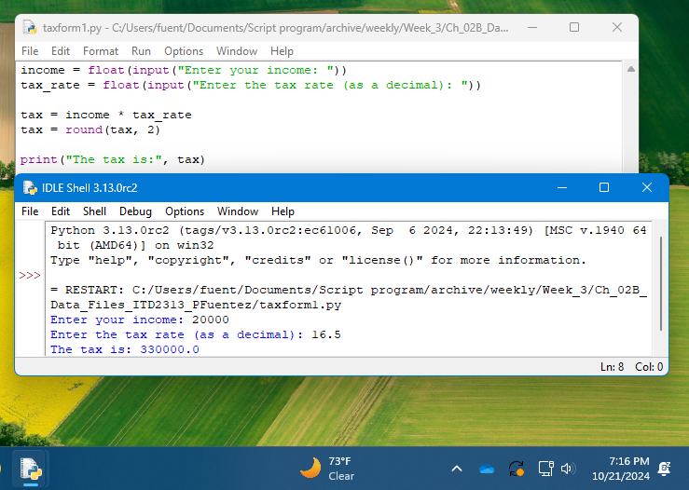
Project # 7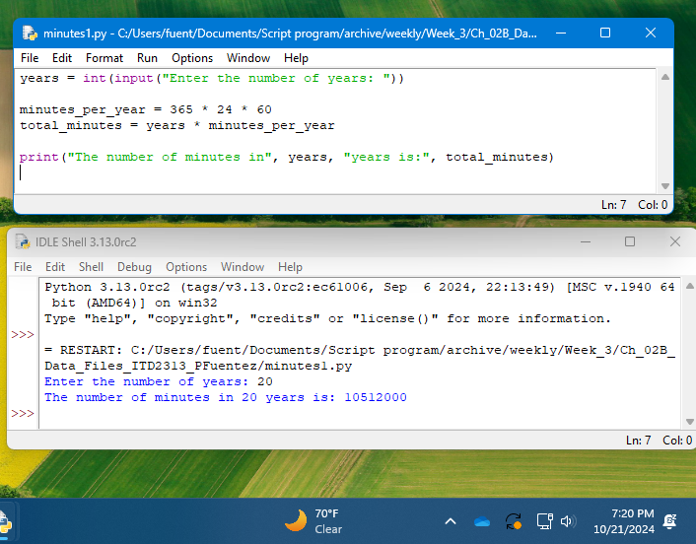
Project # 10